RAPPORT OF THE PROJECT :
Raid kahlerras A3
Hassani fateh A3
1.This project implements a University database using PostgreSQL.
Part I includes the results of the labs, covering DDL, DML, views, functions, transactions, and triggers.
All SQL code is executed using pgAdmin Query Tool.
1.the steps :
1.we start by creating a new data base in pg admin that’s called university
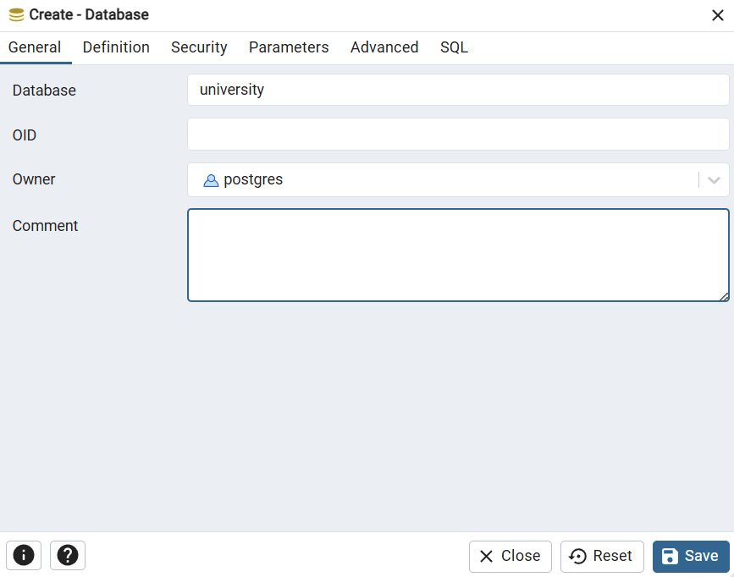
select the querry tool in the new database tha I creat it
and now we start creating the tables needed in thid data base which are (student,department,room,course,reservation,instructor).
using this method we create all the tables in this database using the Annex I for the commands
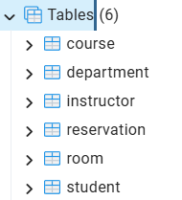 after creating the tables successfully now to the next step
which is inserting the tuples into the the tables one after one and that using The command INSERT
using the Annex || we use the command given to insert the tables with the nedded tupples after correcting some errors that we have in the commands and after that we add it to our main code and use the commenters to make it clear.
after inserting we check tables using the command SELECT:
SELECT * FROM Department;
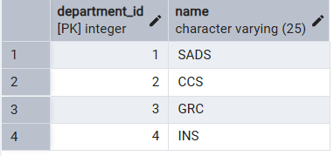
SELECT * FROM Student;
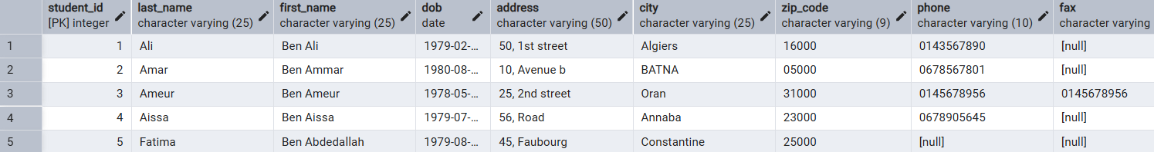
SELECT * FROM Instructor;
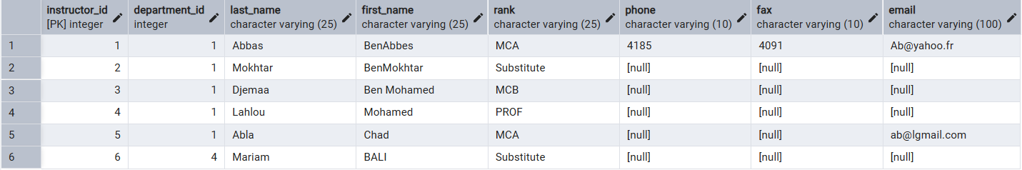
SELECT * FROM Course;
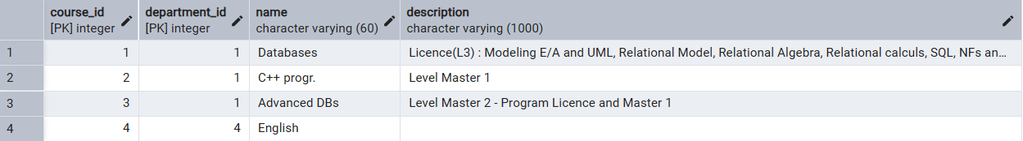
SELECT * FROM Room;
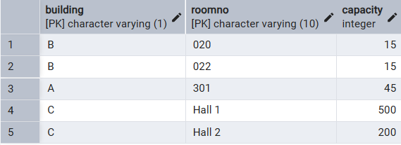
SELECT * FROM Reservation;
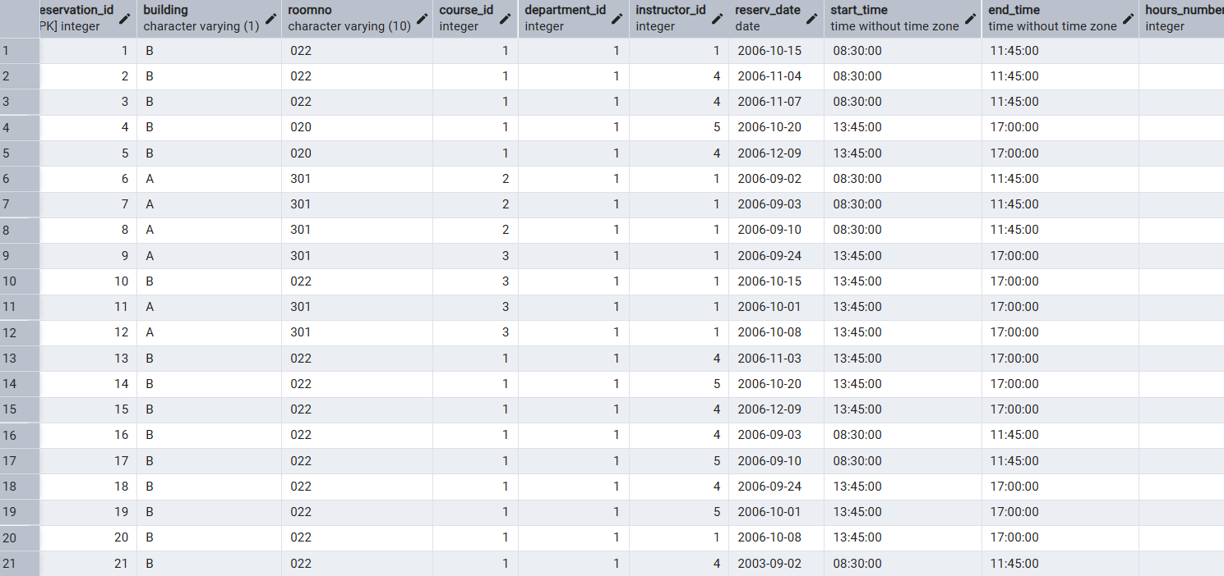
now after checking every table we go to the next ste^p
-- SECTION 2.4: DATABASE EVOLUTION:
in this part he asked us to improve our relation and that withAdd a relation that manages students’ enrollments in courses (should include the date of enrollment) and in this new relation
After establishing the core infrastructure (Students, Instructors, and Rooms), we identified a need to track academic performance and course registration. This phase involves adding the Enrollment and Mark tables to transform a simple scheduling system into a functional Academic Management System.
Enrollment Table (Inscription): This table manages the "Many-to-Many" relationship between Students and Courses. One student can enroll in many courses, and one course can have many students.
Mark Table (Notes):
Purpose: To store the evaluation results for students.
Data Integrity: We implemented a CHECK constraint on the Value column to enforce the standard 0–20 grading scale.
- Logic: Each mark is linked to a specific enrollment, ensuring every grade belongs to a valid student and a valid course.
CREATE TABLE Enrollment (
Student_ID int,
Course_ID int,
Dept_ID int,
Enroll_Date date DEFAULT CURRENT_DATE,
PRIMARY KEY (Student_ID, Course_ID, Dept_ID),
FOREIGN KEY (Student_ID) REFERENCES Student(Student_ID),
FOREIGN KEY (Course_ID, Dept_ID) REFERENCES Course(Course_ID, Department_ID)
);
CREATE TABLE Marks (
mark_id SERIAL PRIMARY KEY,
student_id INT NOT NULL,
course_id INT NOT NULL,
dept_id INT NOT NULL,
mark NUMERIC NOT NULL CHECK (mark BETWEEN 0 AND 20),
mark_date DATE NOT NULL DEFAULT CURRENT_DATE,

FOREIGN KEY(student_id) REFERENCES Student(student_id),
FOREIGN KEY(course_id, dept_id) REFERENCES Course(course_id, department_id)
);
the views :
A view is a virtual table based on the result set of a stored SQL query. It does not store data itself but dynamically shows the query’s results when accessed, making it appear like a regular table. Views are useful since they allow the following: Query simplification: You can save complex or frequently used queries into a view to simplify your SQL code. Security and access control: Views can restrict access to sensitive columns or rows, allowing users to see only necessary data without exposing the entire underlying table. Data abstraction: Views can hide changes in the underlying table structure from users and applications.
The regular view provides a dynamic count of reservations.
Purpose: To aggregate data from the Reservation table without storing it permanently.
Logic: We used the COUNT(*) function because our reservation table identifies bookings by the combination of instructor, room, and date rather than a single ID. We then grouped the results by instructor_id
THE CODE:
CREATE VIEW View_Res AS
SELECT instructor_id, COUNT(*) AS total
FROM Reservation
GROUP BY instructor_id;

